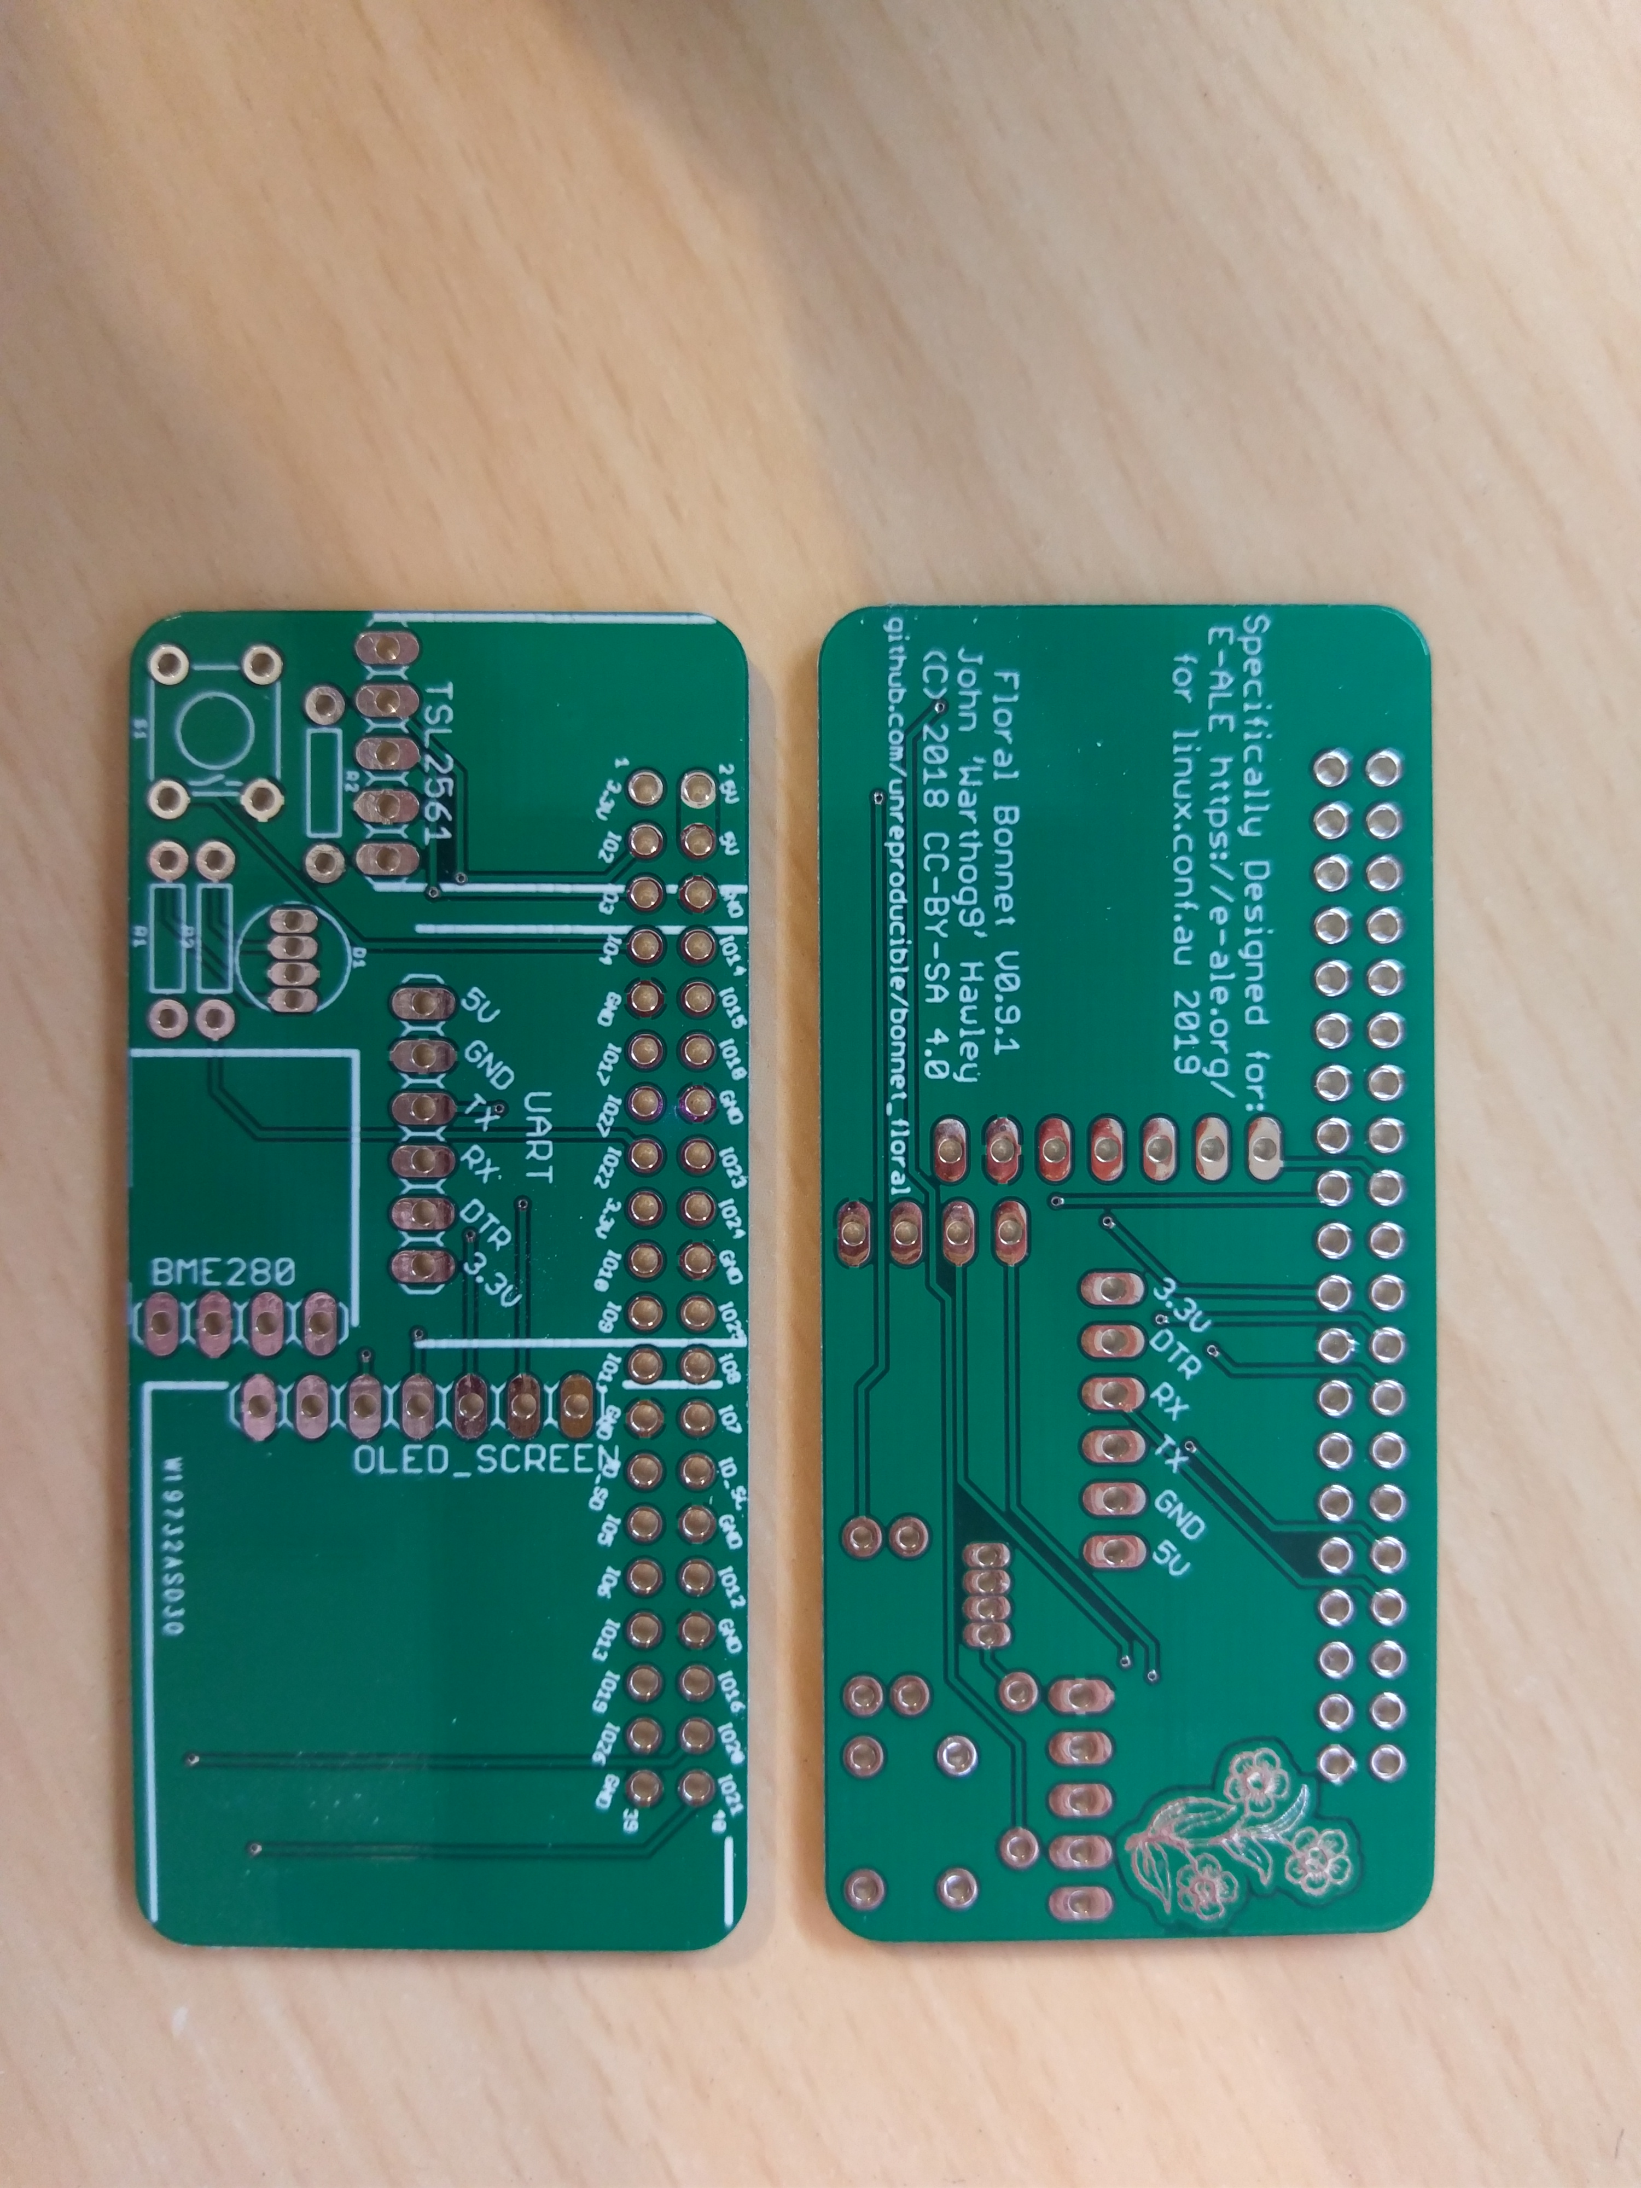
Board Top
IC1
Install this first
(covered by TSL2561, UART and OLED_SCREEN)
Flat Side
Pinout from Left:
Blue, Red, Common Cathode, Green
INT
SDA
SCL
GND
VCC
Note: pinout
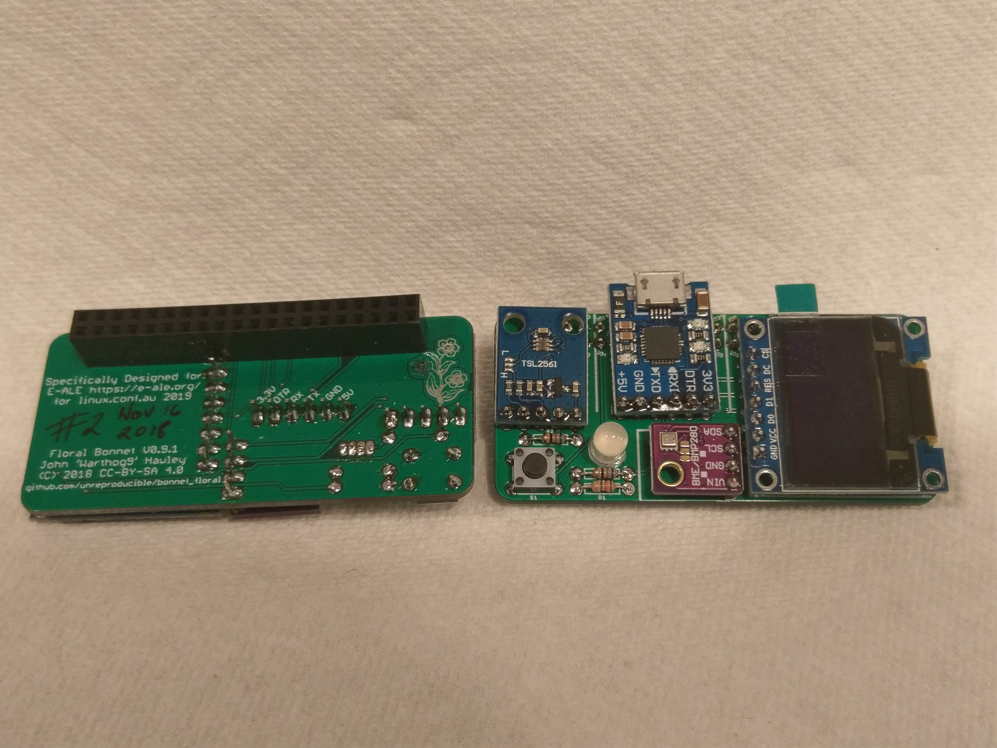
Board Bottom
Board Top
IC1
Components on top
This IC is expected to be on top
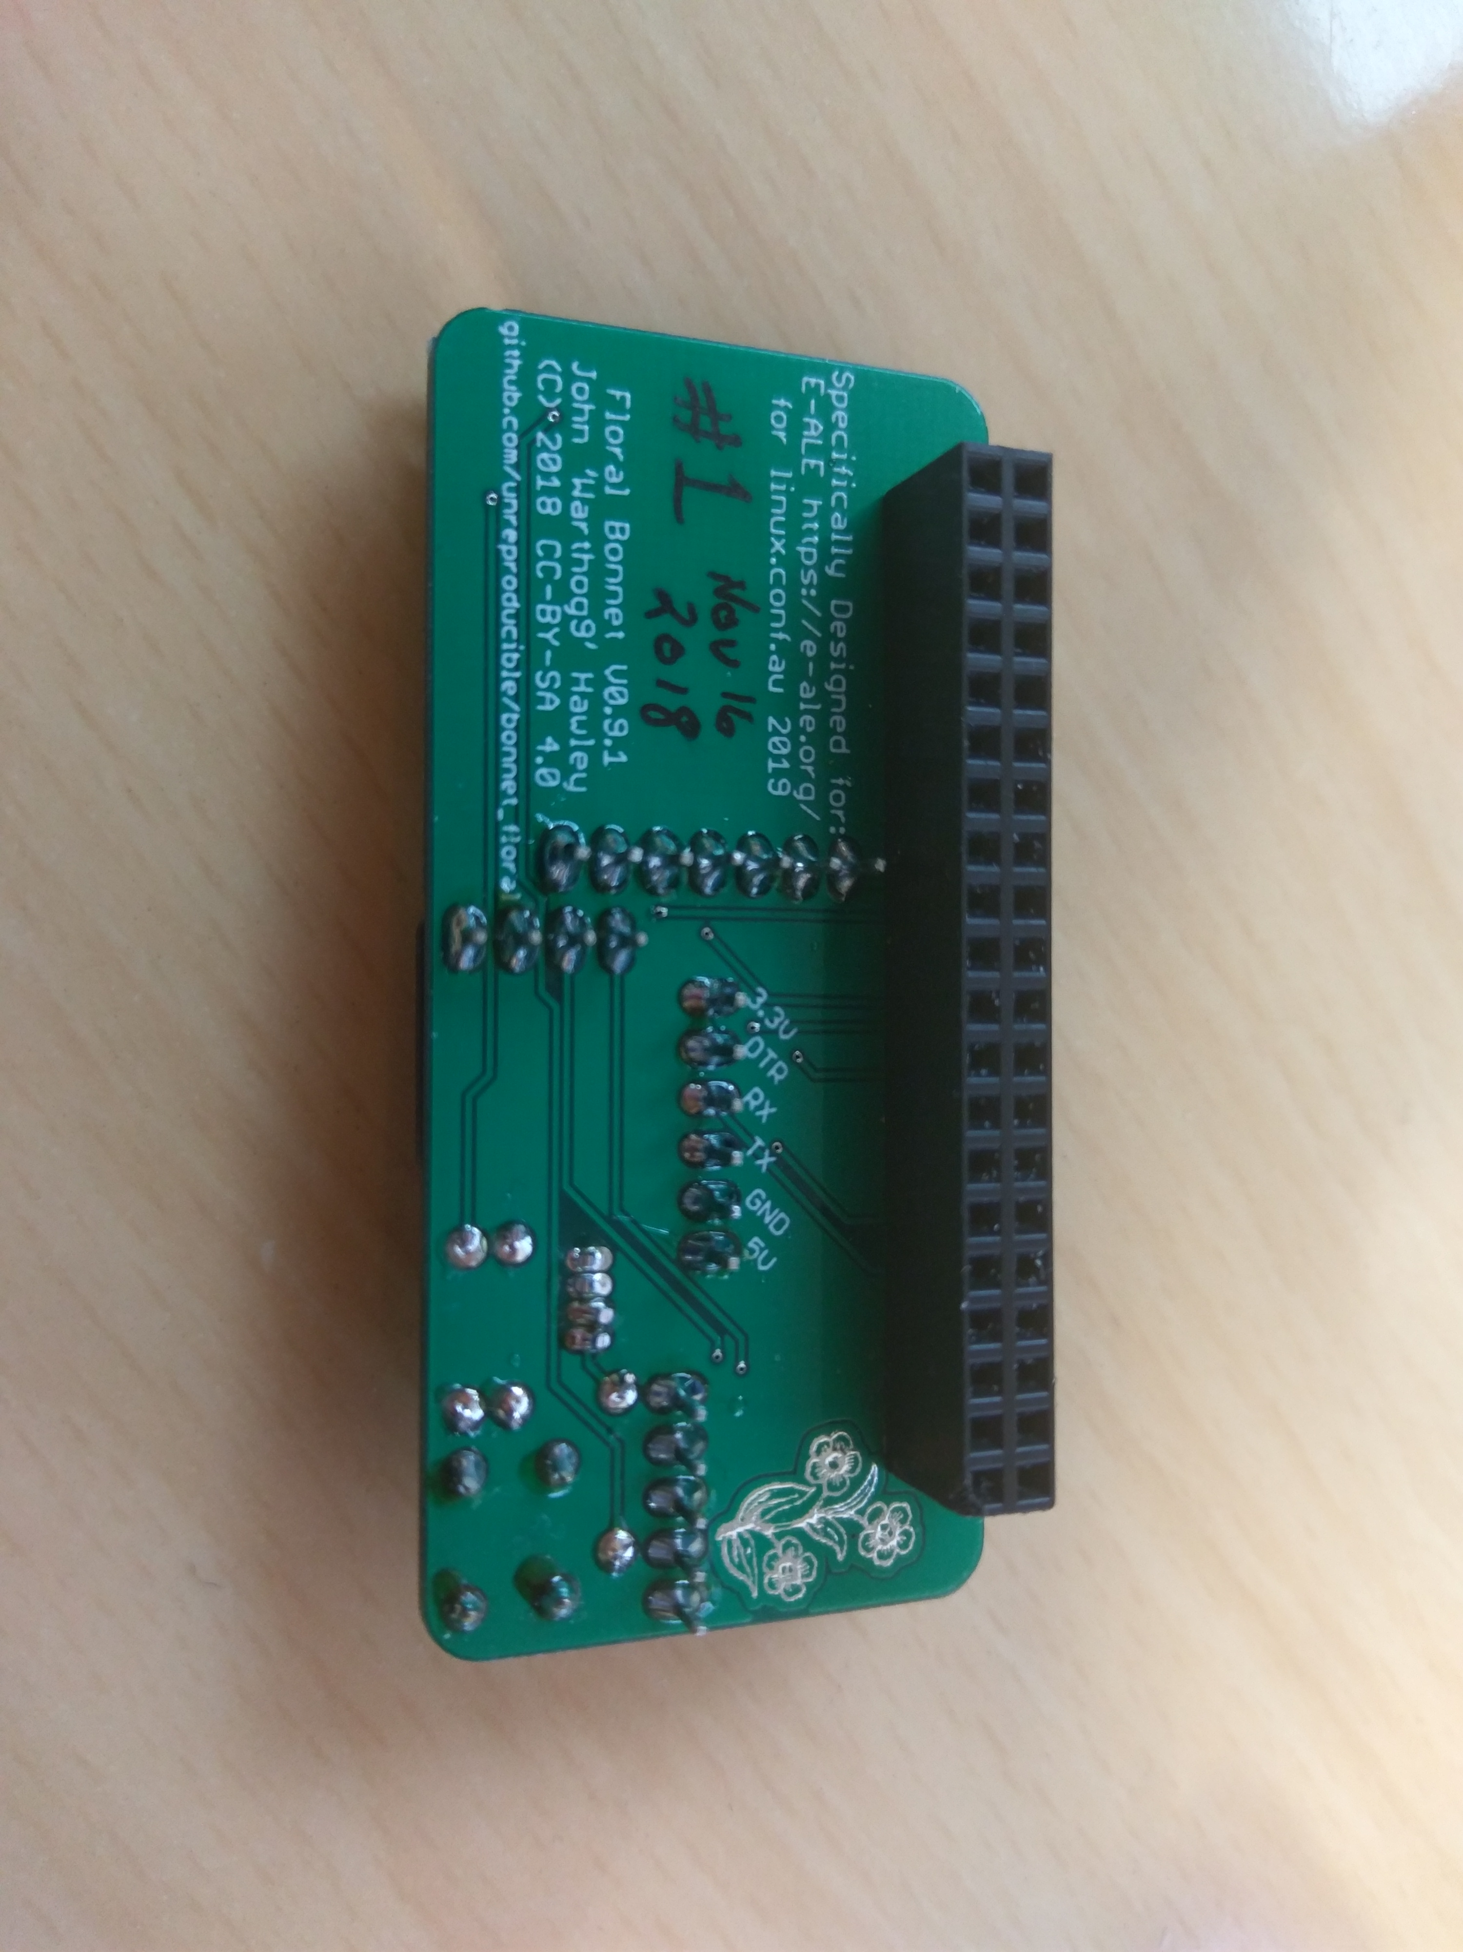
Board Bottom (assembled)
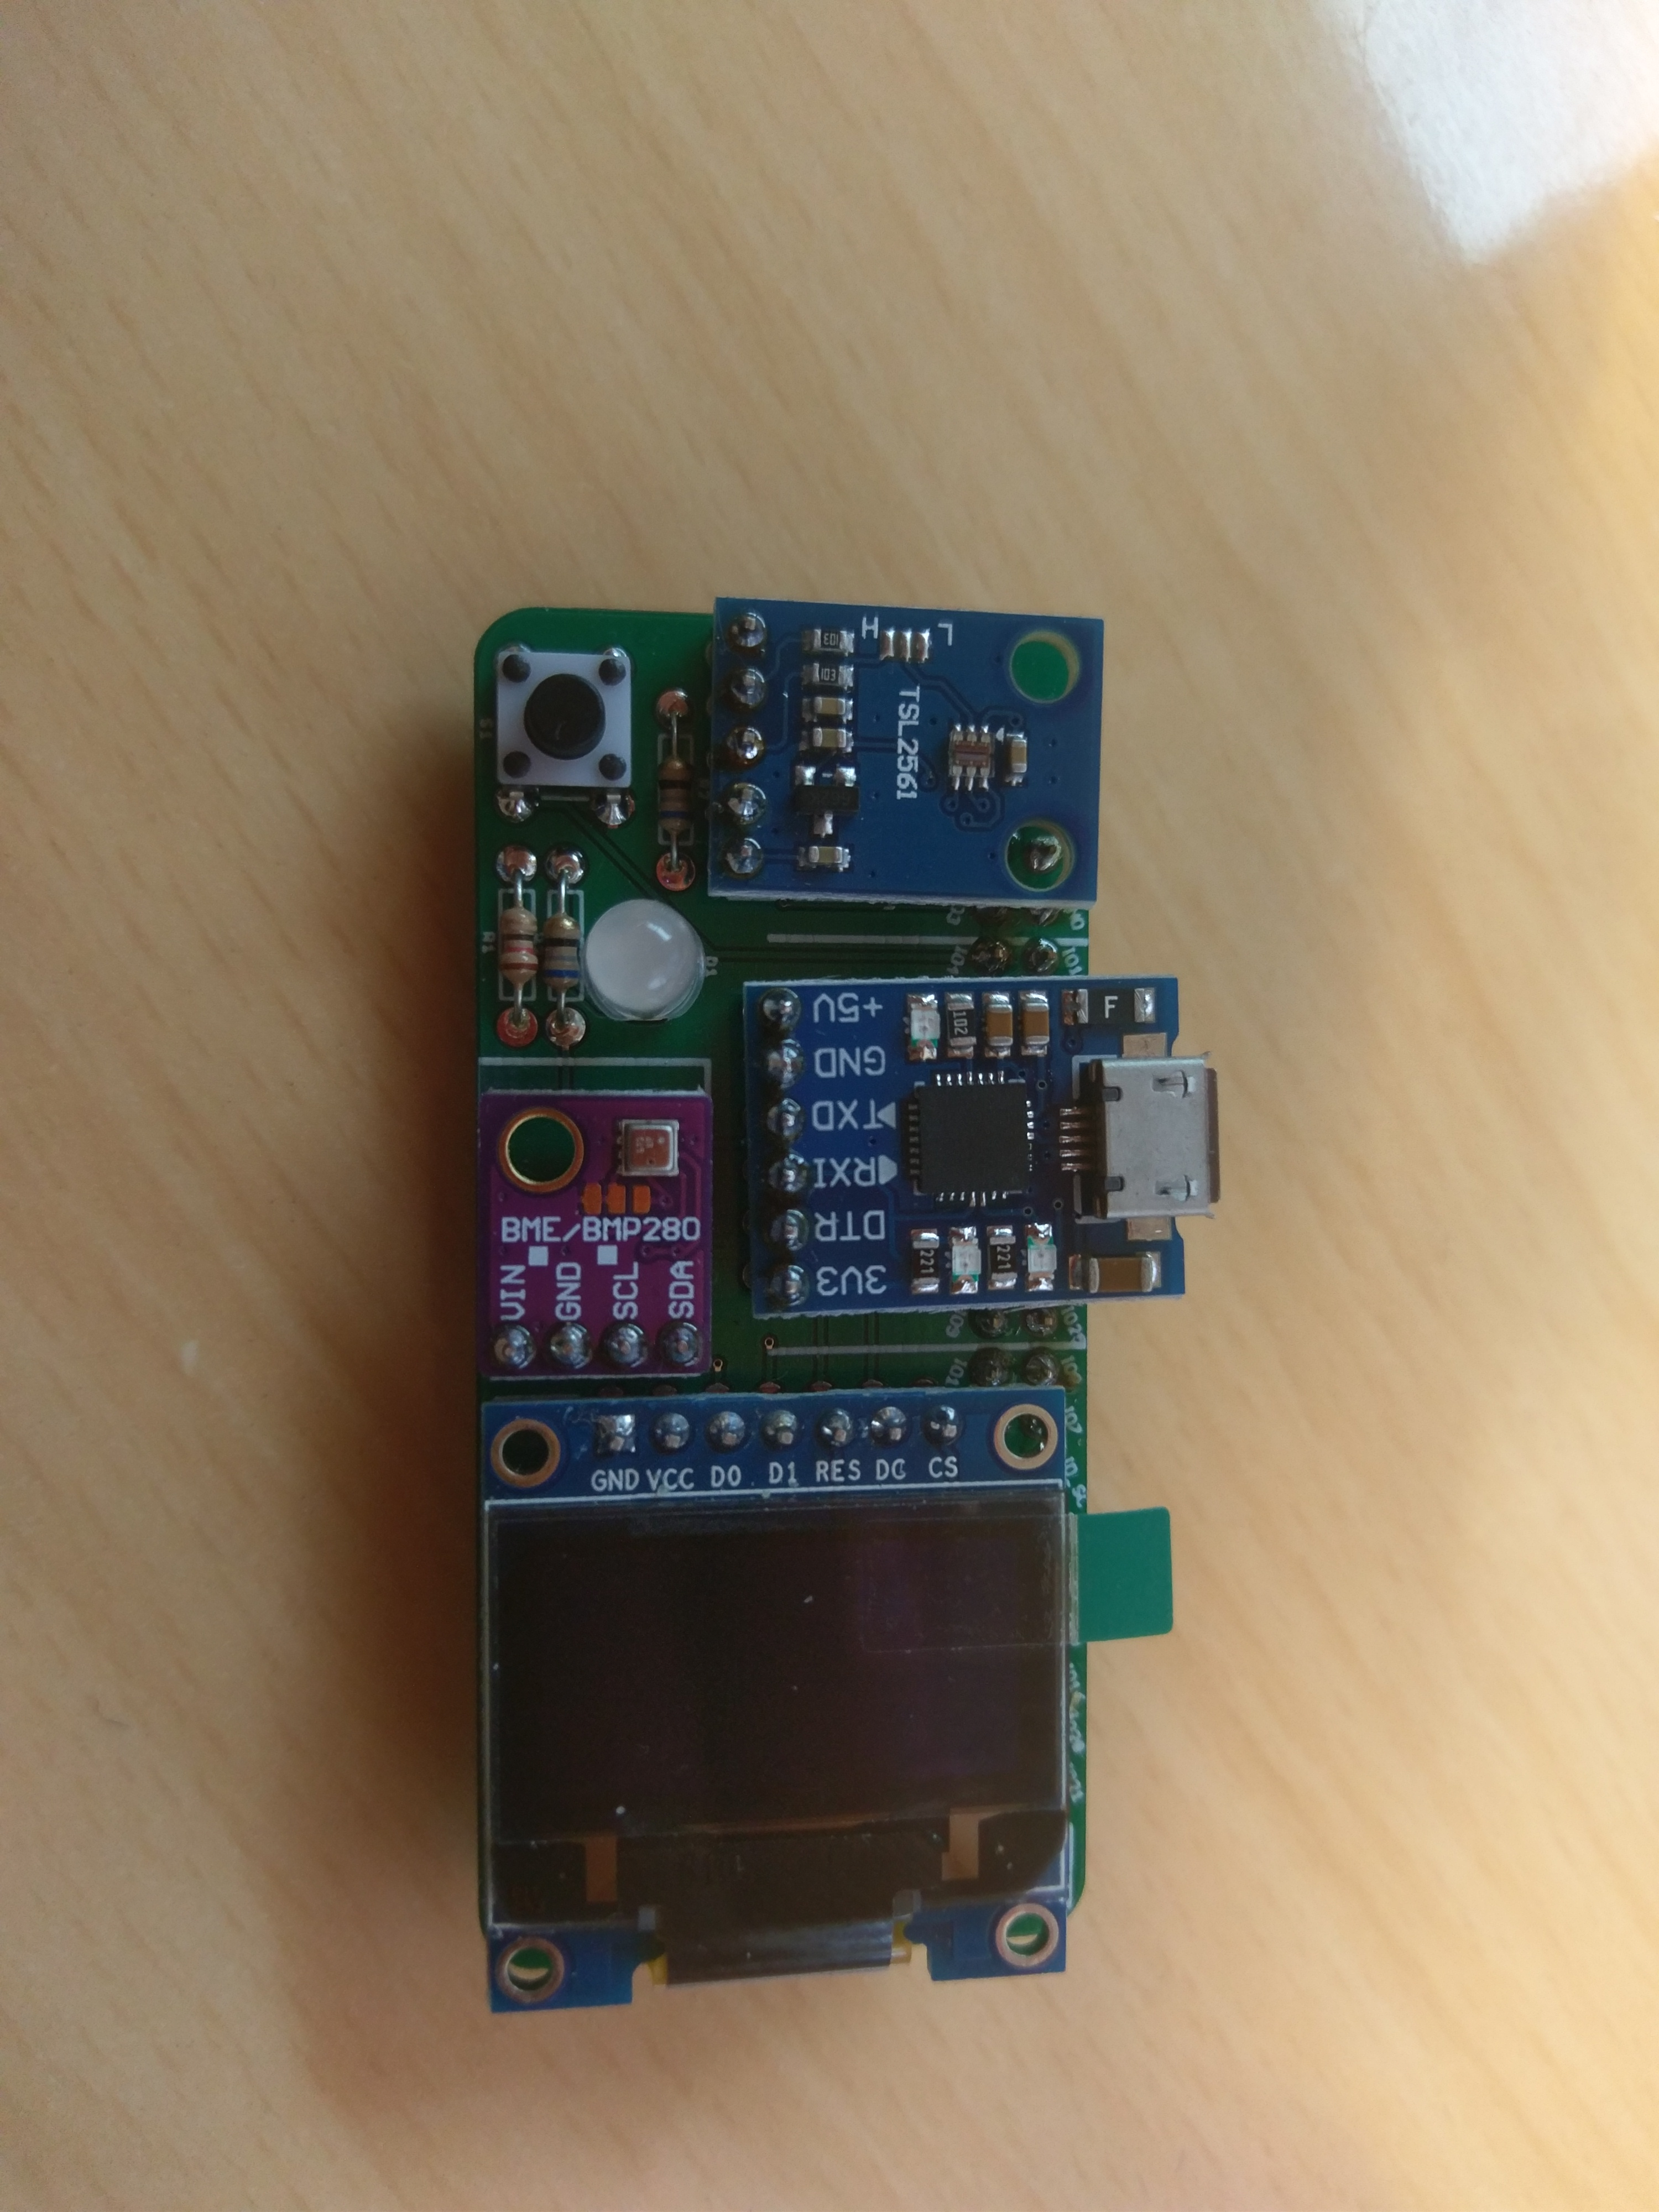
Board Top (Assembled)
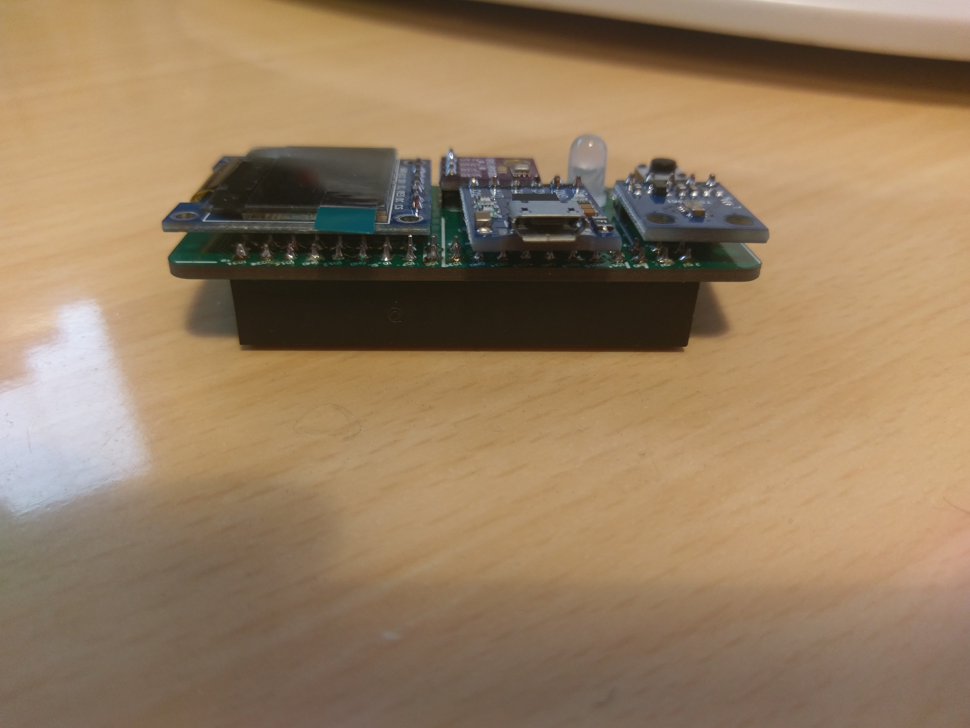
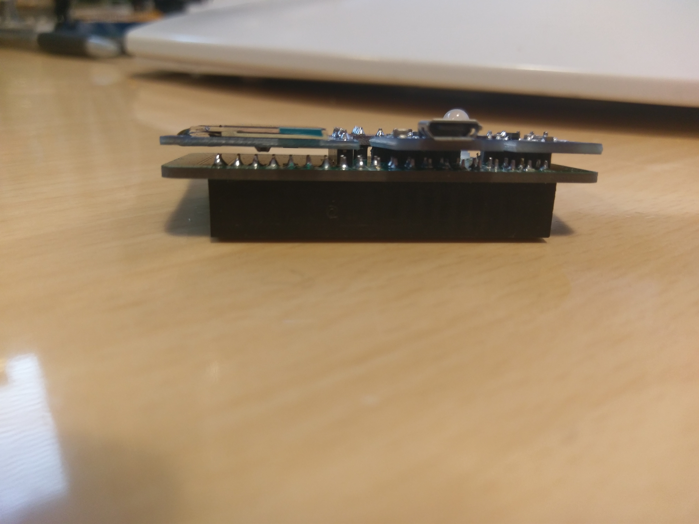
Note: Clearance is tight here between pins from IC1 and Cap on bottom of OLED_SCREEN
Because of clearance (noted left) make sure pin spacer is flat
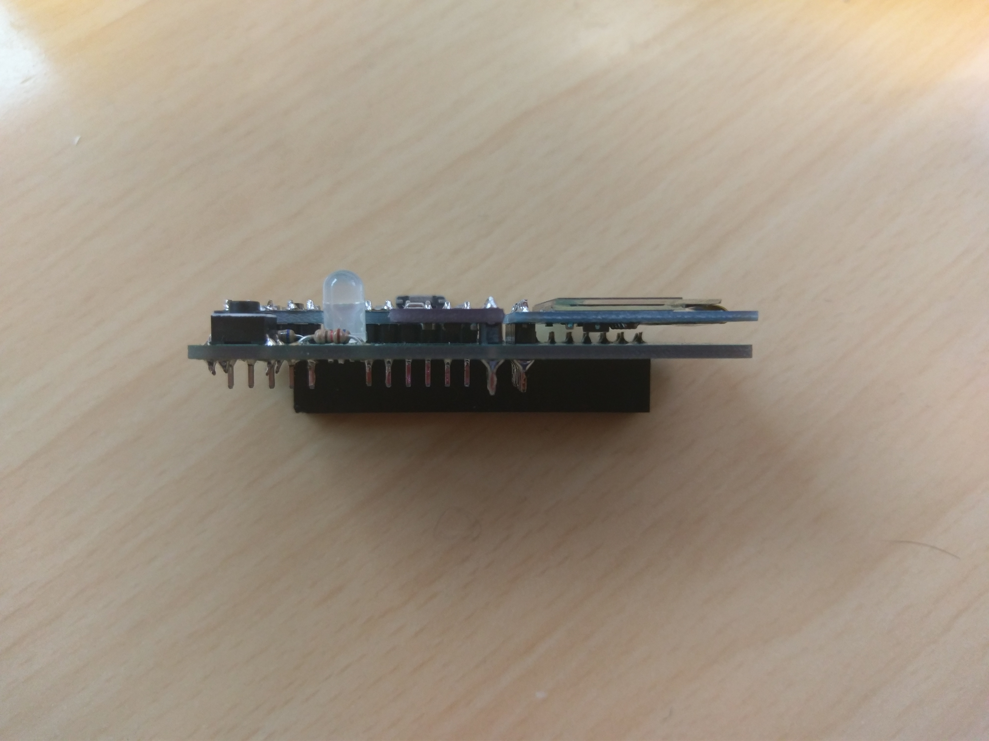
The pins don’t need to be clipped, if it’s a pain


